EXP: 1
Date : 08-07-2026

DDL Commands – CREATE, ALTER, DROP
AIM:
To Create, Alter, Drop, Rename, Truncate using Data Definition Language (DDL) statements.

Description:
Data Definition Language (DDL) statements are used to define the database structure or schema.
DDL Commands: Create, Alter, Drop, Rename, Truncate

PROCEDURE :
Step 1: Create a new database for storing patient details.
Step 2: Select the created database to perform the required operations.
Step 3: Create a table named Patients with the attributes P_id, Patient_Name, Doctor_Name, Disease, Ward, and Blood_Group.
Step 4: Verify the structure of the created table.
Step 5: Insert the patient details into the Patients table.
Step 6: Display all the records in the Patients table to verify that the data has been inserted successfully.
Step 7: Alter the Patients table by adding a new attribute named Insurance.
Step 8: Modify the data type/size of the Insurance attribute as required.
Step G: Rename the Patients table to Patient_Records.
Step 10: Verify that the table has been renamed successfully.
Step 11: Truncate the Patient_Records table to remove all records while retaining the table structure.
Step 12: Verify that all records have been deleted from the table.
Step 13: Drop the Patient_Records table from the database.
Step 14: Verify that the table has been removed successfully from the database.

Query 1:
CREATE TABLE patients ( P_id INT PRIMARY KEY, Patient_Name VARCHAR(50), Doctor_Name VARCHAR(50), Disease VARCHAR(50), Ward VARCHAR(50), Blood_Group VARCHAR(50));

Output 1 :

Query 2:
INSERT INTO patients VALUES (201, 'Ramesh Kumar', 'Dr. Anitha Sharma', 'Diabetes', 'General Ward', 'B+');

Output 2 :

ALTER TABLE patients Add Insurance VARCHAR(15) ;
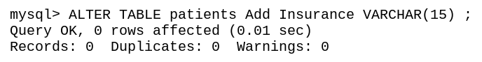

Query 3 :
INSERT INTO patients (P_id, Patient_Name, Doctor_Name, Disease, Ward, Blood_Group)values(203, 'Lakshmi Narayanan', 'Dr. Vikram Rao', 'Fracture', 'Orthopedic Ward', 'O+'), (202, 'Priya Suresh', 'Dr. Anitha Sharma', 'Hypertension', 'Cardiology Ward', 'A+'), (204, 'Arjun Menon', 'Dr. Suresh Babu', 'Appendicitis', 'Surgical Ward', 'AB+');

OUTPUT 3 :
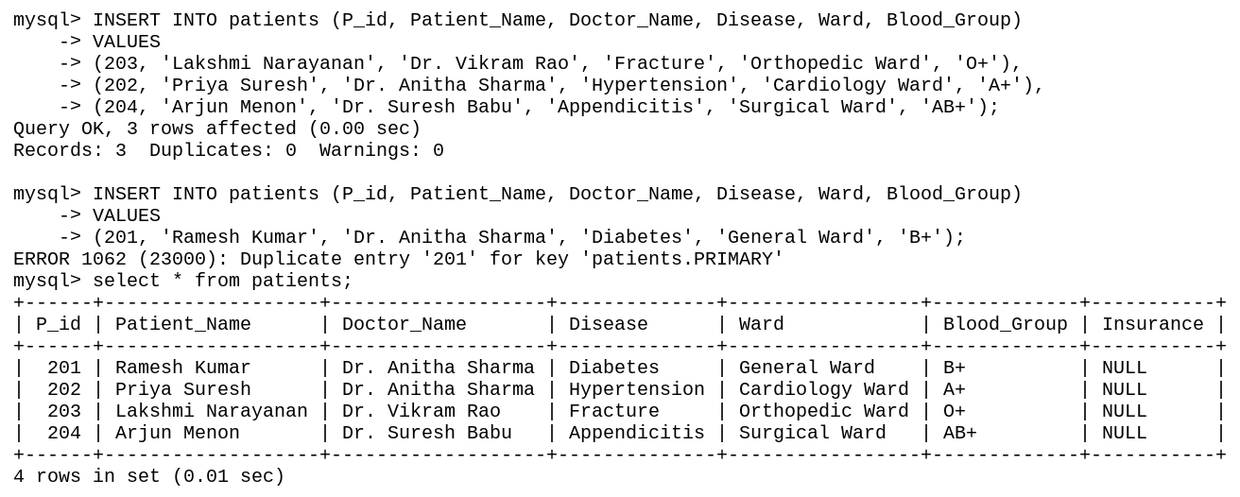

Query 4 :
Desc patients;

OUTPUT 4 :
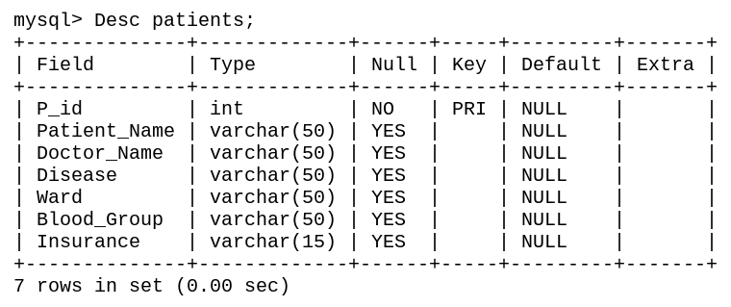

Query 5 :
Truncate table patients;

OUTPUT 5 :
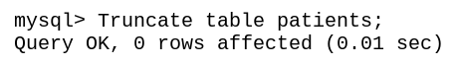

Query 6 :
Drop Table patients;

OUTPUT 6 :
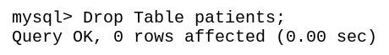

Result : Tables are created, altered and modified using DDL commands.

